Purple Speckled Kidney Bean | Light Speckled Kidney Bean Long Shape | Red Speckled Kidney Beans
Light Speckled Kidney Bean (American Round) | Light Speckled Kidney Beans Long Shape
Navy White Kidney Bean | White Kidney Bean(Medium Type) | Spanish White Kidney Bean
Japanese Type White Kidney Bean |  | White Kidney Bean(Baishake Type)
Dark Red Kidney Beans Guizhou Type | Small red beans | Adzuki(chinese red small bean)
British Red Kidney Bean (Heilongjiang origin)  Black Soybean(Yellow Kernel) Black Bean With Green Kernel | British Red Kidney Bean Shanxi Origin
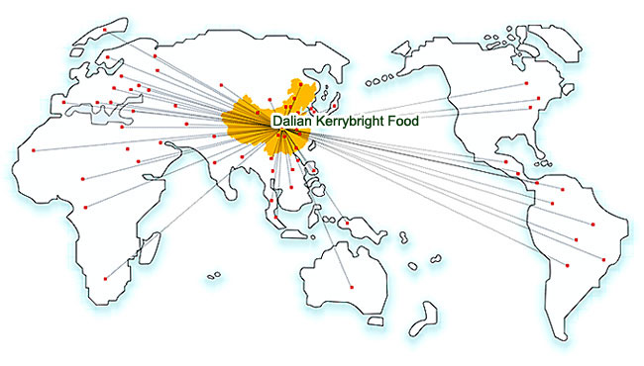
DaLian KerryBright Food Co., ltd, once a semplice exporter of cereals. After years of industrial restructuring and technology upgrading, now spreading her activities to a full business chain of cereals industry. This business chain cover seeds breeding, planting, harvesting, processing, researching and finish product marketing of cereals. KerryBiright is firmly going to be a new star in this scope, in Dalian, even through Northeast Asia.
The newly build workshop covers more than 20,000 Square Meters, equipped with full set high-tech facilities: Sortex color sorters, peeling machine, milling machine, vacuum packing line etc. Our imported new cereal powder processing line, is the first one in Northeast China using levigation technology, which can avoid all short comings of traditional milling technology. Based on this new advanced technology, we also maintain close cooperation relationship with the food technology college of Dalian poly-technic university. A laboratory team leading by Mrs. Zhu PeiWei, academician of the Chinese Academy of Engineering applied more than 3 technical patents and gained national fund support for the laboratory research.

